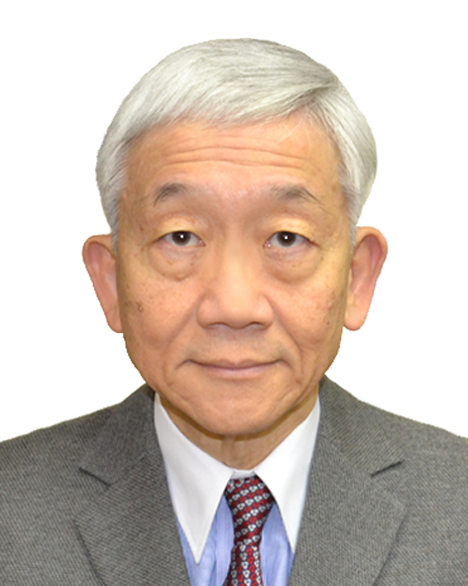
Surname, First name |  | Yang, Philip
Address | Room 302, 3/F, Bupa Centre  No.141 Connaught Road West, Hong Kong
Telephone | +852 2544 1909
Fax | +852 2544 6079
Email | philipyang@biznetvigator.com
Nationality/ Date of Birth | Hong Kong/7th October 1948
Photo
Educational/Professional Memberships
Chartered Arbitrator and Past Chairman (HK Branch, 1990 – 1992) of the Chartered Institute of Arbitrators; Fellow, Institute of Chartered Shipbrokers; Fellow, the Chartered Institute of Logistic and Transport; Associate, Chartered Insurance Institute; Master Mariner
Current Position
Independent maritime and international trade arbitrator.
Professional Experience
Philip is a full-time maritime and international trade arbitrator who has been involved in maritime and international trade disputes since 1980 in Hong Kong, London, Singapore and Beijing.
He is a Fellow, of both the Institute of Chartered Shipbrokers and Chartered Institute of Logistic and Transport. He is an Associate, Chartered Insurance Institute, a Master Mariner and Deputy Chairman of the Documentary Committee, Baltic and International Maritime Council (BIMCO), Denmark.
Arbitration Experience
Philip has published/issued over 500 awards in the past 25 years as sole or co-arbitrator. He is a Fellow and Past Chairman (HK Branch, 1990-1992) of the Chartered Institute of Arbitrators. He is the Honorary Chairman of The Hong Kong International Arbitration Centre (HKIAC)
Publications
Philip has written many books and published papers on international trade, shipping and arbitration related topics/matters.
Languages
English, Cantonese, Mandarin

